**Note:** For deletetemp file copy this file from any server which I have already completed and paste that file in upcoming servers which you are going to do.

**Step 1:** Copy & Paste the deletetemp and deleting temp files 1 XML file in desktop.

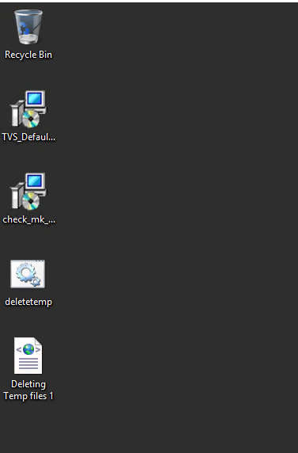

**Step 2:** Then Open Task Scheduler and Click on Import Task on right side of the screen.

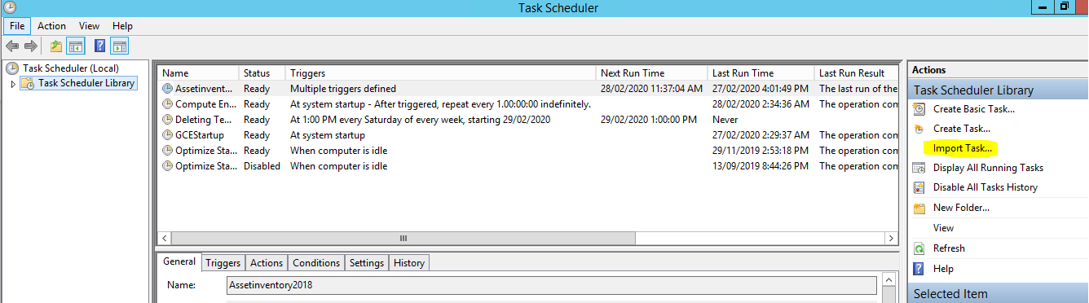

**Step 3:** Then Select the Deleting Temp files 1 XML file in Desktop which we have pasted.

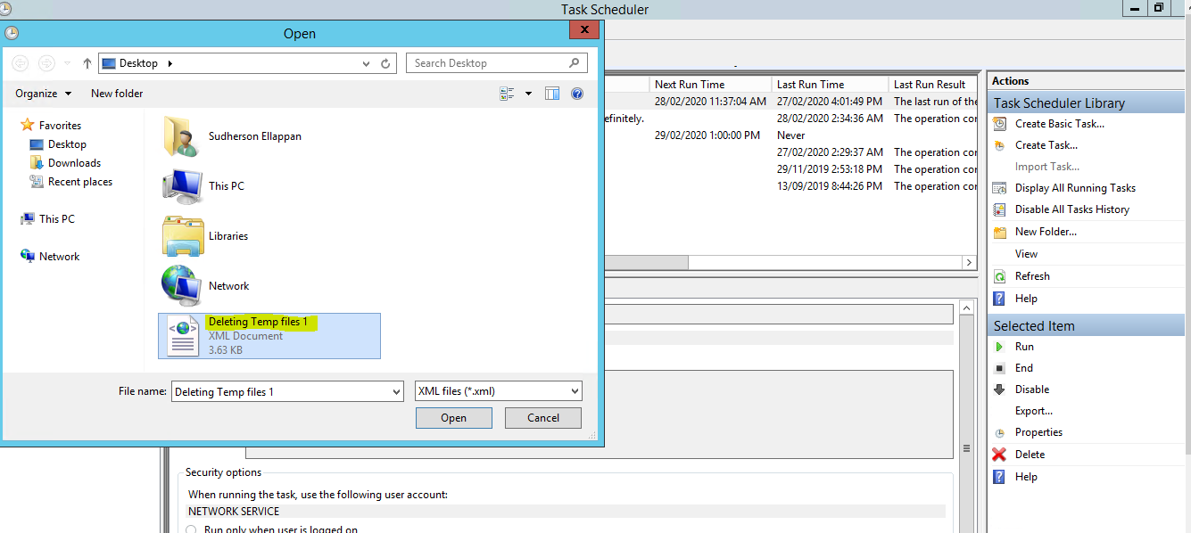

**Step 4:** Ensure that you have selected the Correct OS while clicking Ok.

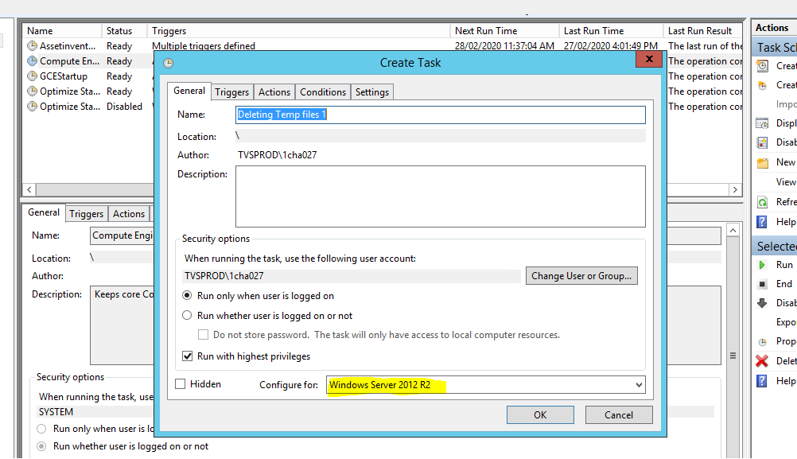

**Step 5:** After Clicking Ok. Ensure that Deleting Temp Files file is present in Library.